# Music Store Data Analysis

# Problem Statement:

You are tasked with analyzing a music store's database to provide meaningful insights into sales performance, customer behavior, and product popularity. The data includes details about customers, artists, albums, tracks, and sales (invoices). Your goal is to write SQL queries that help the store optimize its sales strategy, improve customer targeting, and manage inventory efficiently.

# ER Diagram.

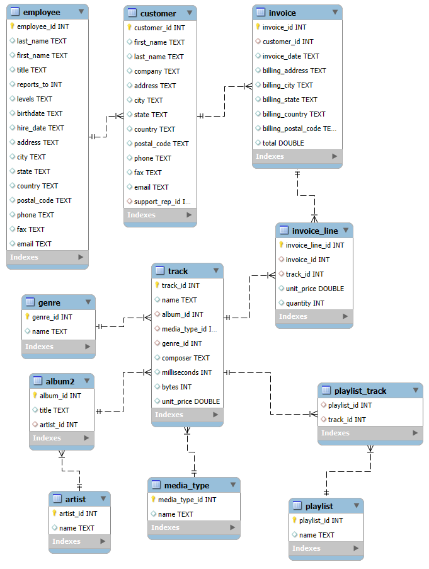

Sales Analysis:

1. What is the total revenue generated by the music store?

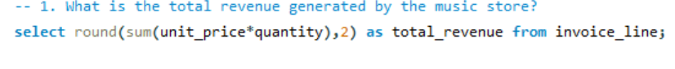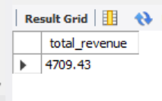

1. Which artist generated the highest revenue?

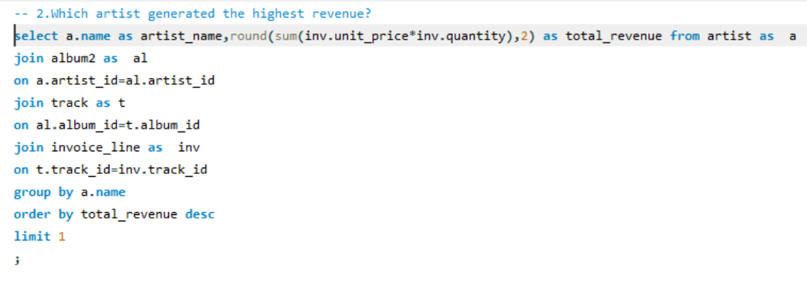

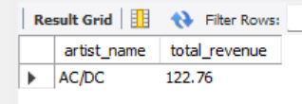

**Insight**: The artist which generated the highest revenue is AC/DC.

**Recommendation**: Promote and feature this artist more often in newsletters, playlists, or homepage banners

1. Which three album has sold the most copies ?

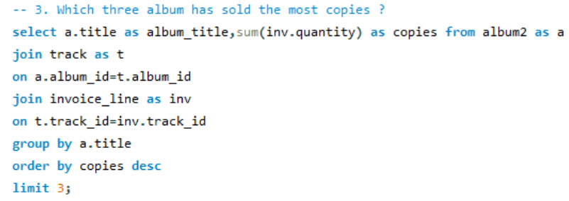

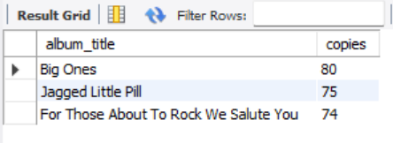

**Insight**: These are the top-selling albums and it reveal customer preferences.

1. What are the total sales per genre?

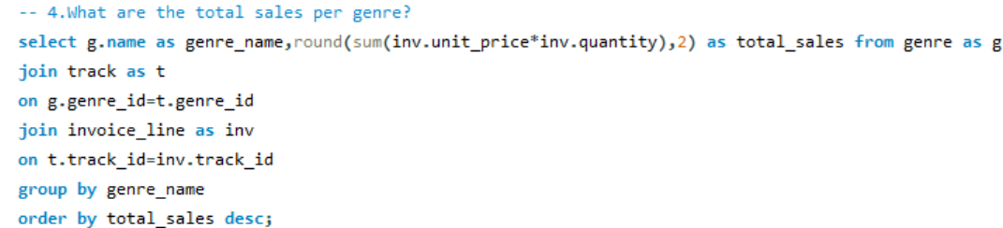

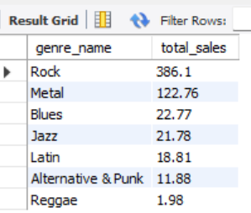

**Insight**: Top selling genre is Rock and lowest is Reggae.

**Recommendation**: Expand inventory and focus recommendations around top genres

5.what are the sales trend over the years?

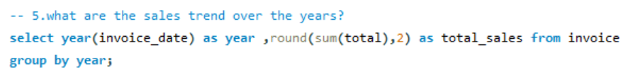

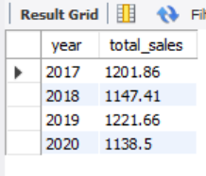

**Insight**: In Year 2019 highest Revenue was generated and in 2020 lowest revenue was generated.

6.what are monthly sales trend ?

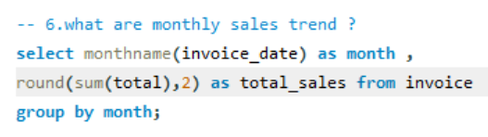

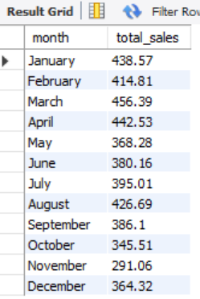

**Insight**: Highest revenue generates in the month of March and lowest in November.

**Recommendation**: Run promotions during low sales months to smooth revenue trends

7. what is the total no of quantity sold by music store?



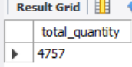

8. Write a query that returns five cities that has the highest sum of invoice totals. Return both the city name & sum of all invoice totals

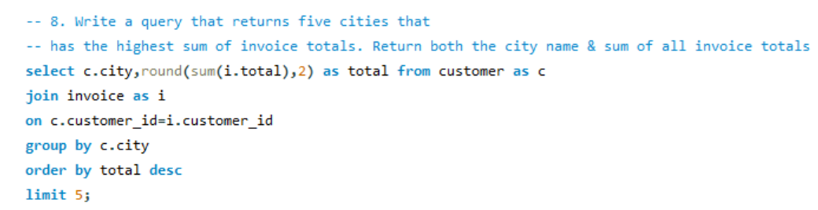

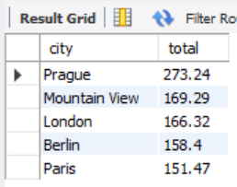

**Insight**: These Cities generate the most sales.

**Recommendation**: Target these cities with localized ads or events.

9. Write a query that returns five cities that has the lowest sum of invoice totals. Return both the city name & sum of all invoice totals

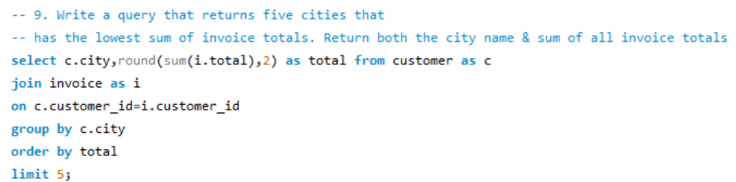

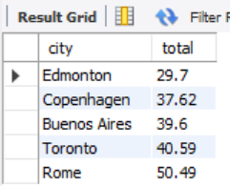

**Insight**: These Cities generates minimal sales.

**Recommendation**: Consider localized promotions, or investigate if language barriers exist.

10.On which days of the week do most purchases happen?

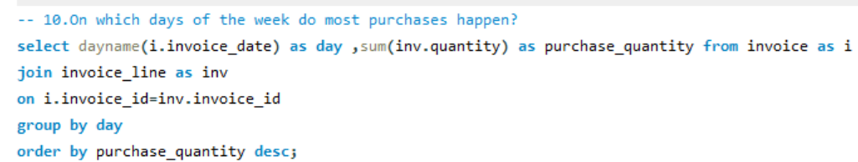

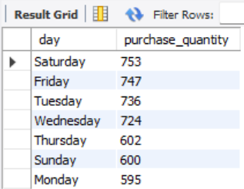

**Insight**: Most purchases happen on **Saturday and Friday**.

**Recommendation**: Schedule promotional emails or discounts on these peak days.

11.Which five countries generate the highest revenue?

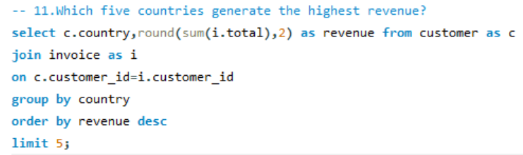

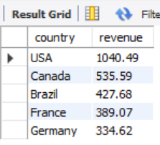

**Insight**: These countries generate the highest revenue.

**Recommendation**: Expand partnerships or artist promotion in these countries.

12.Which five countries generate the lowest revenue?

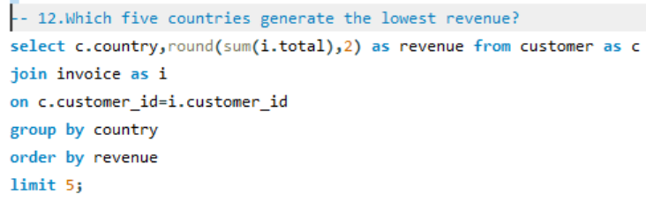

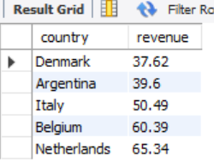

**Insight**: These countries generate the lowest revenue.

**Recommendation**: Use targeted social media ads, offer subscription discounts in these countries.

Customer Insights:

1. Who are the top 5 customers by total purchase amount?

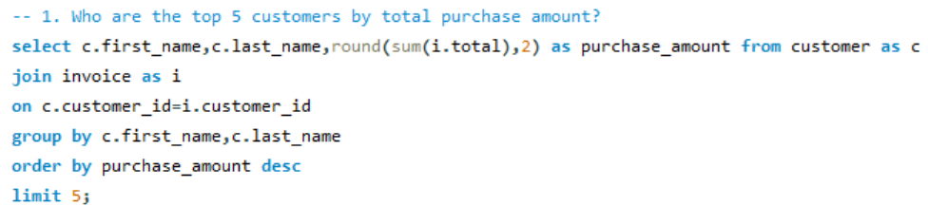

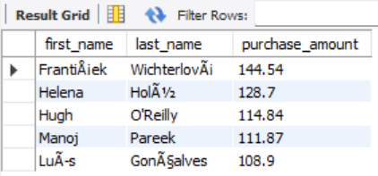

**Insight**: These are the top spenders.

**Recommendation**: Offer loyalty rewards or exclusive content to high-value customers.

1. How many unique customers bought music from each country?

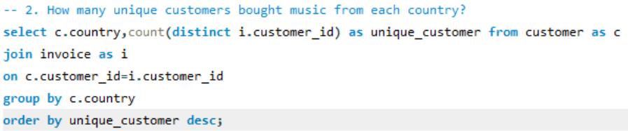

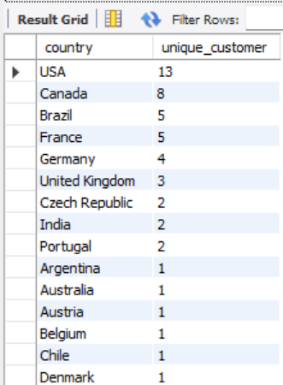

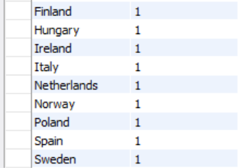

**Insight**: USA has the highest number of unique buyers.

**Recommendation**: Focus marketing efforts in this region for customer acquisition and retention.

3. What is the average purchase value per customer?

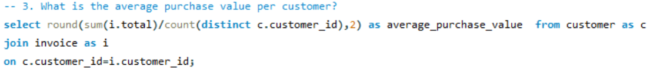

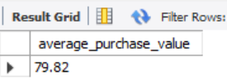

**Insight**: On average, each customer spends **$79.82**.

**Recommendation**: Encourage more purchases per customer with upsells, recommendations, or free shipping thresholds.

4.Write a query that determines the customer that has spent the most on music for each country.

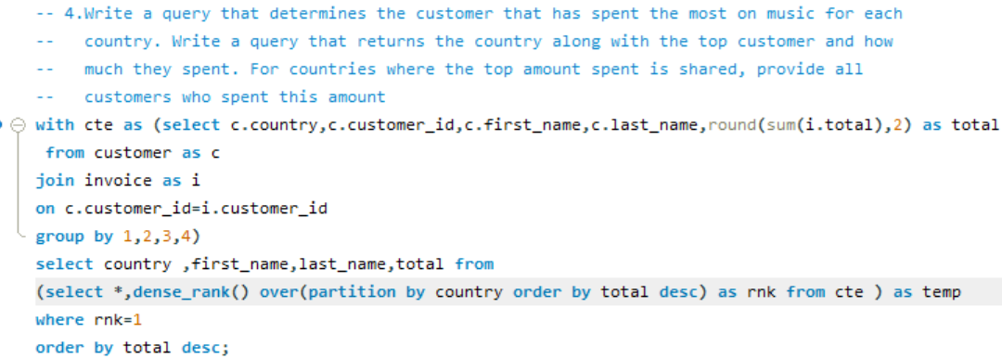

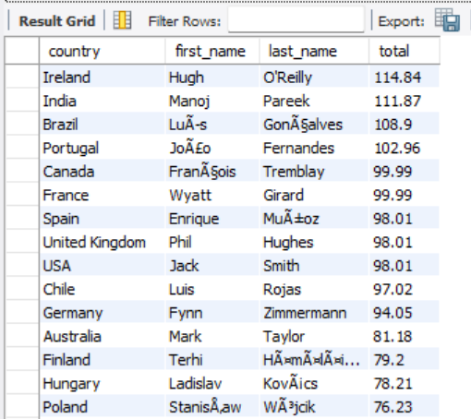

**Insight**: These are the Top spenders from each country.

**Recommendation**: Build localized loyalty programs or recognize these users with VIP rewards.

Product Popularity:

1. Which track is the most popular by number of sales?

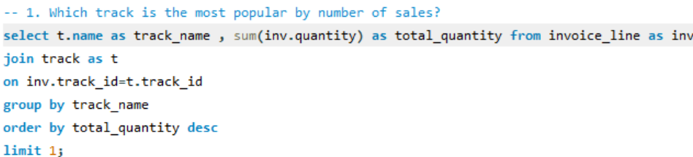

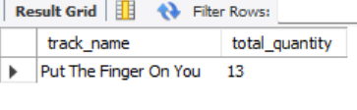

**Insight**: The track **Put The Finger On You** is the most sold.

**Recommendation**: Feature this song in playlists and suggest similar tracks.

1. What is the average price of tracks by genre?

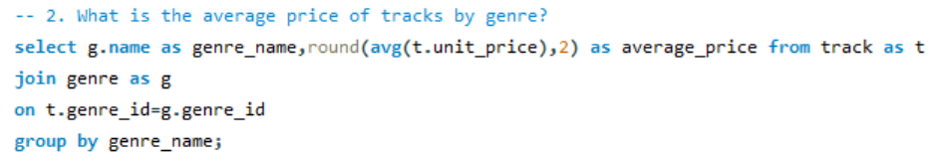

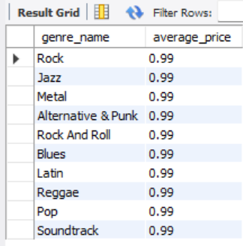

**Insight**: All tracks have same average price.

3.List tracks that have never been sold.

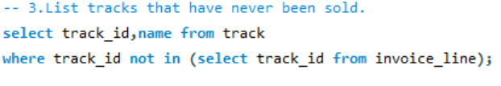

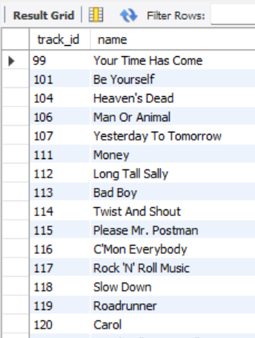

**Insight**: These are tracks that have never been sold

**Recommendation**: Evaluate these for removal, bundling, or retargeting with new marketing strategies.

4 . Which is the most popular genre?

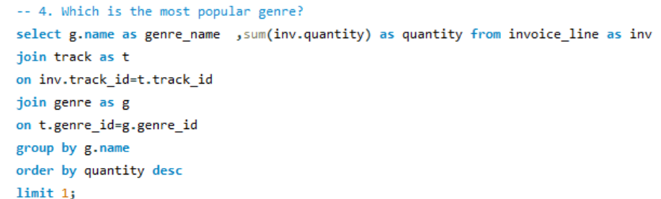

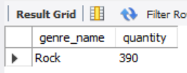

**Insight**: **Rock** is the genre which is most purchased by quantity.

**Recommendation**: Expand catalog and curate genre-specific offers.

5.Identify five albums that are top-selling per artist.

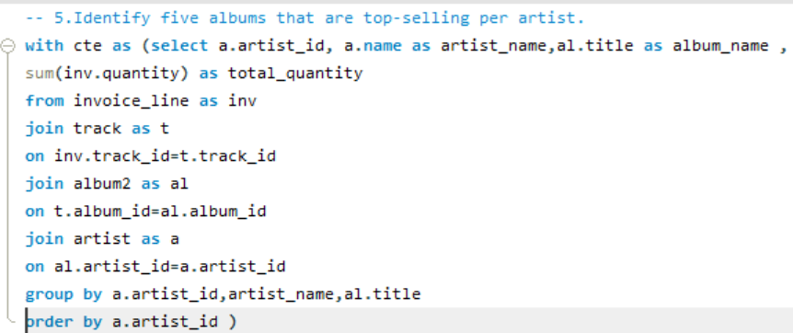

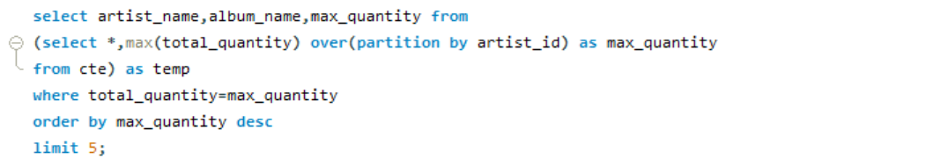

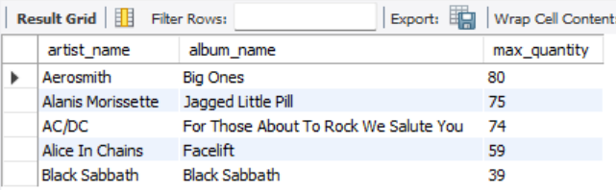

**Insight**: These are the artist and their top selling album.

**Recommendation**: Use this to curate best-of lists or promote sequels/spinoffs.

6 .We want to find out the most popular music Genre for each country. We determine the most popular genre as the genre with the highest amount of purchases. Write a quer that returns each country along with the top Genre. For countries where the maximum number of purchases is shared return all Genres

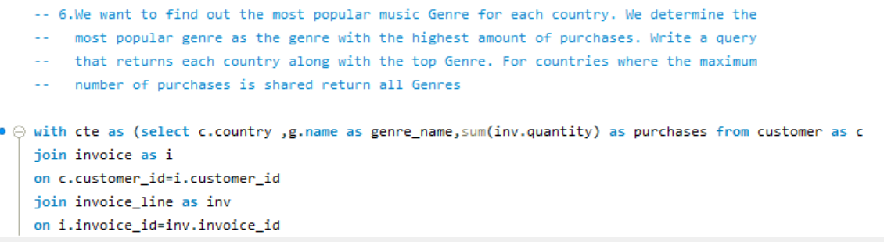

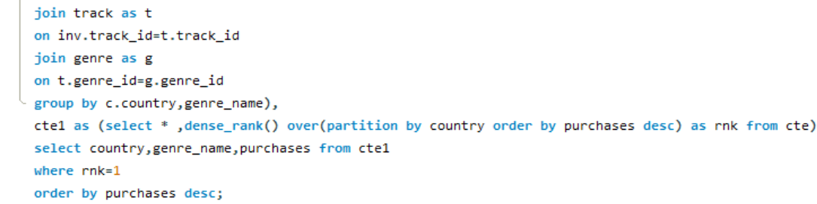

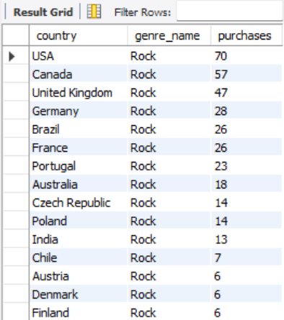

**Insight**: **Rock is most popular in almost many country.**

**Recommendation**: Localize music offerings and marketing by country preferences.

7.Return all the track names that have a song length longer than the average song length.

Return the Name and Milliseconds for each track. Order by the song length

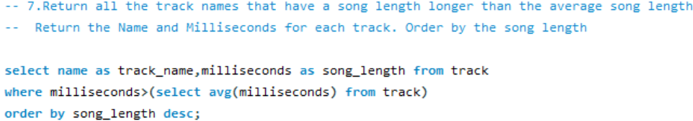

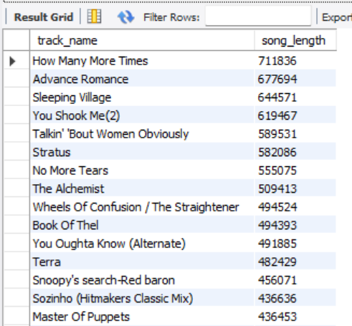

**Final Summary:-**

This project explored the sales, customer, and product data of a digital music store using SQL. Through structured querying and business-focused analysis, we derived key insights that reveal how revenue is distributed across regions, what products are most profitable, and which customer segments offer the highest value.

Key findings include:

* A small number of artists and albums contribute to a majority of the store’s revenue.
* Rock and Pop genres dominate in both popularity and average price.
* Several tracks and albums have never been purchased, revealing opportunities to optimize the product catalog.
* Top-spending customers and high-revenue countries suggest where to focus loyalty and marketing efforts.
* Underperforming countries like Brazil and Chile highlight the need for localized promotion and pricing strategies.

Throughout this analysis, SQL was used to write optimized, multi-table queries involving joins, aggregations, common table expression and window functions to answer real-world business questions.